Bluenose Ghosts Festival 2018
Volunteer Release of Liability and Damage Waiver

I______________________________ will participate as a volunteer for the Bluenose Ghosts Festival, with roles at any or all of the attractions including the Fear the Darkness Haunted House, Selfie haunted Park , Trick or treat House and Buried Alive Casket Ride, between the dates of January 1, 2018 through to december 31,2018. As an event volunteer in any or all capacities of construction and operation of the attractions, I understand that Management must be notified of all incidents related to guest problems, injuries or illness related to volunteers and/or guests, equipment failure and/or safety violations.
As a volunteer, I understand that my actions are viewed by the public and directly affiliate me with the Bluenose Ghosts Festival, Alderney Landing and event sponsors. I understand that if my actions are deemed inappropriate, my volunteer duties will be cancelled and I will be removed from the event site without a warning. If I fail to cooperate, further measures may be taken to ensure the safety and security of all patrons, staff and volunteers.
I do not hold Alderney Landing and/or its affiliates responsible for damage or loss of property, and/or injury or death to myself during the preparation of, or while participating in, the Bluenose Ghosts Festival. I fully acknowledge the risks of participating in this event and hereby forfeit my right to penalty, lawsuit, and/or legal action against the stated parties.

I __________________________________________________ have read and understand the
Print Name
Safety Training, Emergency Action Plan, and Inspection Manuals on the date of

_______________________________________
Day/Month/Year

______________________________________________________________
Signature
_______________________________________________________________
(if under the age of 18 years old) Parent or Guardian's signature
________________________________________________________________
Witness

Emergency contact________________________________________________ ___________________________________
NAME NUMBER
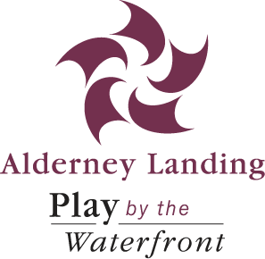

Alderney Landing Community Cultural Centre
PO Box 725 – 2 Ochterloney Street Dartmouth,
NS B2Y 3Z3 (902) 461-4698
(Please complete the form and return to Fear The Dartmouth Haunted House)

USE OF IMAGE CONSENT FORM
□ I hereby consent to the image of my child/children (or my image if 18 years of age or older) being photographed, videotaped and/or interviewed by employees or agents of the Alderney Landing Association in the course of their duties.
In providing consent, I understand these images can be used on websites, social media sites (Twitter, YouTube etc.) and other materials to promote The Bluenose Ghosts Festival and the Fear the Darkness Haunted House.
□ I do not consent to the image of my child/children (or my image if 18 years of age or older) being photographed, videotaped and/or interviewed by Alderney Landing Association.

_____________________________ ____________________________
Name Phone Number

_____________________________
Signature (if over 18)

_____________________________ _________________________________
Parent Signature (if under 18) Parent Name and Phone Number

